**FACULTY OF TECHNOLOGY**

**EASTERN UNIVERSITY, SRI LANKA**

**Examination Time Table (Revised on 14.02.2025)**

**Second Year First Semester Examination in Biosystems Technology –2022/2023**

**(January- February, 2025) 2021/2022 intake - Proper**

**Venue: Auditorium, Faculty of Technology**

|  |  |  |  |  |
| --- | --- | --- | --- | --- |
| **Date** | **Code** | **Title of Course** | **Time** | |
| **Theory** | **Practical** |
| **27.01.2025** | BST 23012 | Introduction to Aquaculture | 09.30am-10.30am | **-** |
| **28.01.2025** | - | 09.00 – 03.00 pm  **(Groups-1,2,3)** |
| **29.01.2025** | BST 23072 | Agribusiness Management | 09.30am-11.30am | **-** |
| **30.01.2025** | BST 23032 | Principles of Food Preservation Technology | 09.30am-10.30am | **-** |
| **31.01.2025** | - | 09.00 – 03.00 pm  **(Groups-1,2,3)** |
| **03.02.2025** | MDS 23032 | English for Technology –III | 09.30am-11.30am |  |
| **05.02.2025** | BST 23062 | Water Management Technology | 09.30am-10.30am | **-** |
| **06.02.2025** | - | 09.00 – 03.00 pm  **(Groups-1,2,3)** |
| **07.02.2025** | MDS 23021 | Workshop Technology | - | 09.00 – 04.00 pm  **(Groups– 1,2,3)** |
| **10.02.2025** | MDS 23012 | Design Technology | 09.30am-10.30am | **-** |
| **11.02.2025** | - | 09.00 – 03.00 pm  **(Groups-1,2,3)** |
| **13.02.2025** | BST 23022 | Molecular Biological Techniques | 09.30am-10.30am | **-** |
|  | - | **-** |
| **17.02.2025** | MDS 23041 | Career Development | 09.30am-04.00pm | **-** |
| **19.02.2025** | BST 23022 | Molecular Biological Techniques (Practical) |  | 09.30 – 11.30 am |

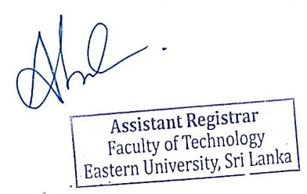

……………………..

Assistant Registrar

Faculty of Technology

14.02.2025