**Submission of Exam Entry form**

**4th  Year 2nd Semester Examination in Biosystems Technology**

**Academic Year - 2021/2022**

**2018/19 Intake – Proper**

Students are requested to collect the Exam entry form the AR office, Faculty of Technology from 10.03.2025 and submit before 17.03.2025.

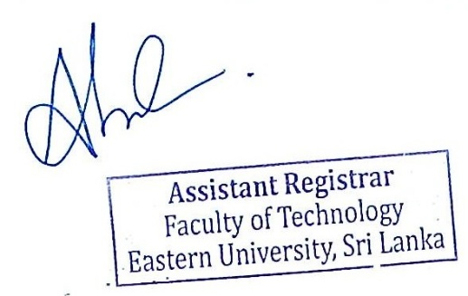

Assistant Registrar

Faculty of Technology

10.03.2025