**EASTERN UNIVERSITY, SRI LANKA**

**FACULTY OF TECHNOLOGY**

**Examination Time Table**

**Fourth Year Second Semester Examination in Biosystems Technology – 2021/22**

**(March, 2025) 2018/19 – Intake Proper**

**Venue: Auditorium, Faculty of Technology**

|  |  |  |  |  |
| --- | --- | --- | --- | --- |
| **Date** | **Code** | **Title of Course** | **Time** | |
| **Theory** | **Practical** |
| **20.03.2025** | **BST 48012** | **Research Methodology** | 09.30am -11.30am | - |

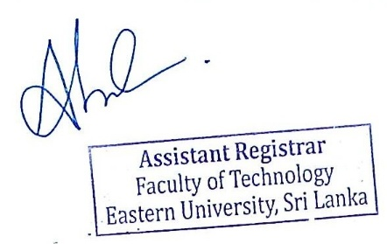

**Assistant Registrar**

Faculty of Technology

10.03.2025